**Home Loan Calculator Application**

Functional Specifications

**I. Introduction**

Upon the recommendation of the Senior Vice President and Chief Technical Officer of **KeefeRance Leasing and Finance Corporation**, the management approved the enhancement to the existing web page of the company to virtually assist potential home loan applicants in computing their monthly amortization if they desire to engage with the company in securing a short to medium term home loan assistance. This enhancement intends to assist the company in efficiently driving more home loan requests by reducing call center operation assistance cost 24/7 and in turn securing answers directly thru the page, 24/7.

**II. Scope**

The Home Loan Calculator Application shall be created as both a micro-site, a widget in any of the identified pages of the company’s website which only shows the form with the identified fields as can be found in *Figure 1* and which navigates to the main page of the Home Loan Calculator Application with the requested values and the Amortization Schedule table, see *Figure 2* **or** accessed from the **Home Calculator** navigation link in the header navigation bar.

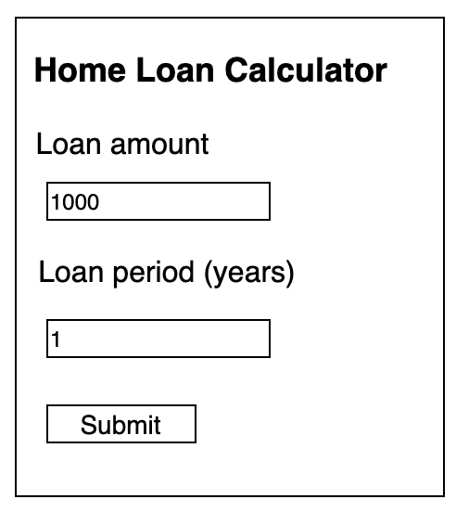

*Figure 1* – Home Loan Calculator widget

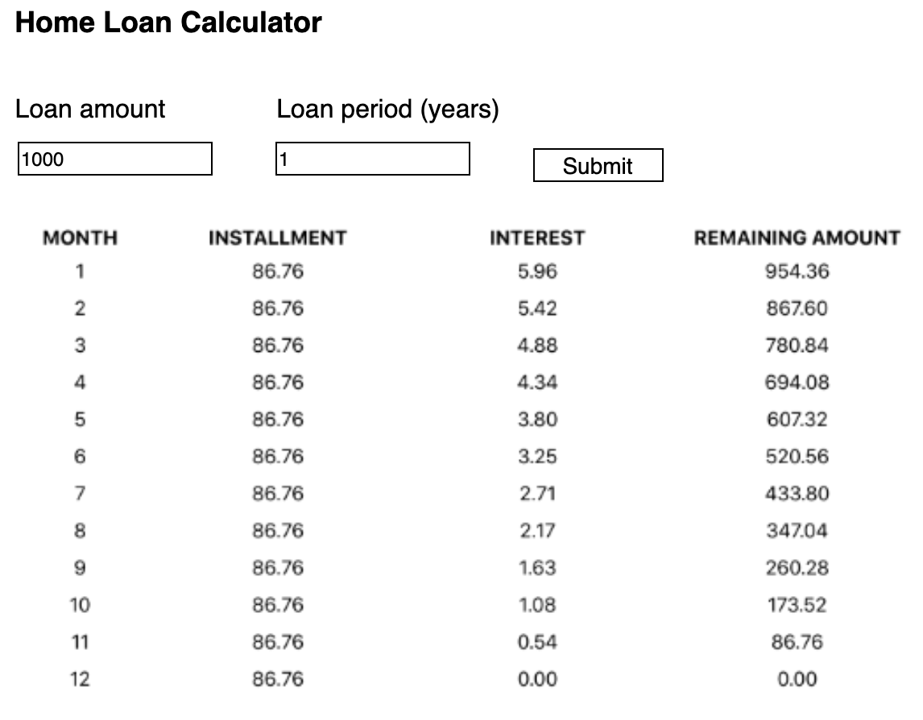

*Figure 2* – Home Loan Calculator main page

**III. Use Cases**

**Use Case 1** - As a user, I would like to use a fixed interest rate of 3.5% per year on my house loan, so that I can see my monthly interest and principal, see *Figure 3*below

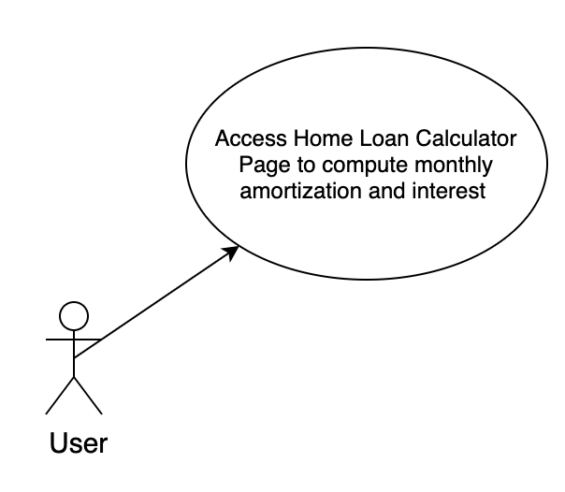

*Figure 3*

**IV. Functional Requirements**

**Home Loan Calculator Form**

The title of the main page shall be Home Loan Calculator using the h1 tag.

The form will consist of 3 elements, the loan amount, loan period, and the submit button. The interest rate is fixed at 3.5% and is assumed during computation of the amortization table. Both the loan amount and loan period shall have Loan amount and Loan period (years) labels respectively and shall both accept only positive, non-zero numbers. The amortization table will not display on page load if the access point is the navigation link. If the access is from a widget, the request values will be passed to the form when the page is navigated to the main Home Calculator page. The amortization table shall consist of four columns, namely: MONTH, INSTALLMENT, INTEREST, and REMAINING AMOUNT. The row values will be displayed as horizontally center aligned. The number of rows displayed corresponds to specified loan period multiplied 12 showing the total number of monthly amortizations labeled under MONTH column. The INSTALLMENT column shall display the fixed monthly payments. The INTEREST column displays the monthly interest for the balance of the total loan amount which can be shown on the last column, REMAINING AMOUNT.



*Figure 4*